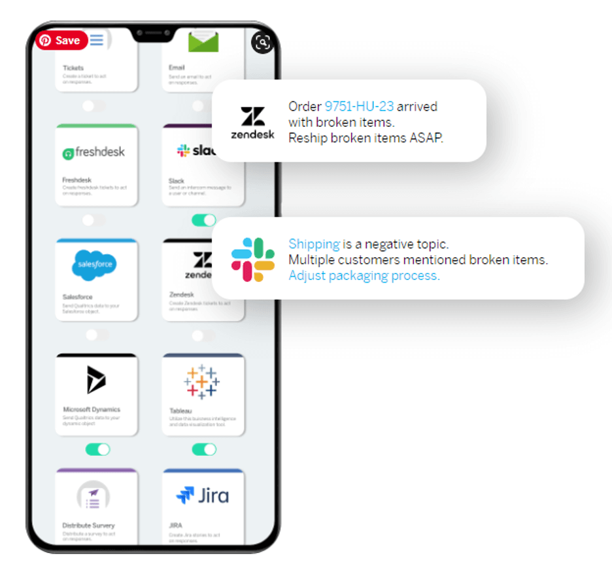  Customer Churn Prediction Using Statistical Analysis and Machine Learning | Anubhav Roy  MSc Statistics

Abstract
Customer churn is a major challenge faced by subscription-based businesses, as losing existing customers directly impacts revenue and long-term growth. Identifying customers who are likely to discontinue their services allows organizations to implement targeted retention strategies and improve customer loyalty. This study focuses on analyzing customer characteristics associated with churn and developing a predictive model to identify potential churners using statistical analysis and machine learning techniques.
The study uses the Telco Customer Churn dataset, consisting of customer demographic information, service details, contract information, and billing attributes. Exploratory Data Analysis (EDA) was performed to identify patterns and relationships among customer attributes. Statistical techniques, including the Chi-square test of independence and Welch’s t-test, were applied to examine the association between contract type and churn, as well as the difference in monthly charges between churned and retained customers.
A Logistic Regression classification model was developed after appropriate data preprocessing, including categorical variable encoding and feature scaling. The model achieved an accuracy of 78.96% and an ROC-AUC score of 0.828, indicating good predictive performance. However, the lower recall for churned customers highlights the challenge of identifying all potential churn cases in an imbalanced dataset.
The findings suggest that factors such as contract type, customer tenure, and monthly charges play an important role in customer retention behaviour. The study demonstrates how statistical analysis combined with machine learning can provide valuable insights for organizations seeking to reduce customer churn and improve retention strategies.

Introduction
In today's competitive business environment, customer retention has become a critical factor for the long-term success of organizations. With increasing competition among service providers, acquiring new customers often requires significant investment, making it essential for companies to understand customer behaviour and reduce customer loss. Customer churn, which refers to the process of customers discontinuing their relationship with a company, can have a direct impact on revenue, profitability, and business growth.
Subscription-based industries such as telecommunications, banking, and digital services frequently face the challenge of identifying customers who are likely to leave. By analyzing customer demographics, service usage patterns, contract details, and billing information, organizations can identify factors contributing to churn and take proactive measures to improve customer retention.
Data analytics and machine learning provide effective approaches for understanding and predicting customer churn. Statistical methods help identify significant relationships between customer characteristics and churn behaviour, while machine learning models can classify customers based on their likelihood of leaving.
This study aims to analyze customer churn patterns using exploratory data analysis, statistical hypothesis testing, and machine learning techniques. The study utilizes the Telco Customer Churn dataset, which contains customer demographic details, service-related information, contract characteristics, and billing attributes. Statistical techniques such as the Chi-square test of independence and Welch’s t-test are applied to examine significant relationships between customer attributes and churn. Furthermore, a Logistic Regression model is developed to predict customer churn based on relevant features.
The objective of this project is not only to build a predictive model but also to derive meaningful business insights that can help organizations design effective customer retention strategies.

Why Customer Churn Analytics?
Customer churn analytics plays an important role in helping organizations understand customer behaviour and identify factors that influence customer retention. In competitive markets, retaining existing customers is often more cost-effective than acquiring new ones, making churn reduction a key business objective.
Analyzing customer churn enables organizations to identify customers who are at a higher risk of leaving and take proactive measures to improve customer satisfaction and loyalty. By examining customer demographics, service usage patterns, contract details, and billing information, businesses can discover the major factors contributing to customer dissatisfaction.
From a data analytics perspective, customer churn is an important problem because it involves the application of statistical techniques and machine learning methods to extract meaningful insights from customer data. Statistical analysis helps determine significant relationships between customer attributes and churn behaviour, while predictive models assist in identifying potential churners before they leave.
Therefore, customer churn analytics provides both predictive and actionable insights, allowing organizations to make data-driven decisions, optimize retention strategies, and improve long-term customer relationships.

Data Description and Source
Data Source
The dataset used in this study is the Telco Customer Churn Dataset, which is a widely used dataset for customer retention and churn prediction analysis. The dataset is publicly available on Kaggle and is based on a fictional telecommunications company. It contains customer-level information related to demographics, subscribed services, account details, and customer churn status.
Dataset Source:
Kaggle – Telco Customer Churn Dataset
https://www.kaggle.com/datasets/blastchar/telco-customer-churn

Data Description
The dataset consists of 7,043 customer records and 21 variables. Each observation represents an individual customer, while the variables describe different characteristics related to customer profile, service usage, billing information, and churn status.
The target variable for prediction is:
Churn
- Yes – Customer discontinued the service
- No – Customer continued using the service
The variables in the dataset can be categorized into the following groups:

1. Customer Demographic Information
Variable | Description
Gender | Gender of the customer
SeniorCitizen | Indicates whether the customer is a senior citizen
Partner | Whether the customer has a partner
Dependents | Whether the customer has dependents

2. Customer Account Information
Variable | Description
CustomerID | Unique identifier assigned to each customer
Tenure | Number of months the customer has stayed with the company
Contract | Type of customer contract (Month-to-month, One year, Two year)
PaperlessBilling | Whether the customer uses paperless billing
PaymentMethod | Method used for payments

3. Service Information
Variable | Description
PhoneService | Whether the customer uses phone services
MultipleLines | Availability of multiple phone lines
InternetService | Type of internet service subscribed
OnlineSecurity | Whether online security service is subscribed
OnlineBackup | Whether online backup service is subscribed
DeviceProtection | Whether device protection service is subscribed
TechSupport | Whether technical support service is subscribed
StreamingTV | Whether streaming television service is subscribed
StreamingMovies | Whether streaming movie service is subscribed

4. Billing Information
Variable | Description
MonthlyCharges | Amount charged to the customer every month
TotalCharges | Total amount paid by the customer during their association with the company

The dataset provides a combination of numerical and categorical variables, making it suitable for applying exploratory data analysis, statistical hypothesis testing, and machine learning classification techniques for customer churn prediction.

Limitations of the Study
Although this study provides useful insights into customer churn behaviour and develops a predictive model, it has certain limitations that should be considered.
- Dataset Limitation
The study uses the Telco Customer Churn dataset, which is a publicly available dataset based on a fictional telecommunications company. Therefore, the findings may not completely represent real-world customer behaviour in actual organizations.
- Limited Number of Features
The analysis is based on the variables available in the dataset. Additional factors such as customer satisfaction scores, service complaints, competitor pricing, customer feedback, and marketing interactions could provide deeper insights into churn behaviour.
- Class Imbalance
The dataset contains a higher proportion of non-churned customers compared to churned customers. This imbalance may affect the model's ability to correctly identify all potential churners, particularly reducing recall for the churn class.
- Model Selection Limitation
The study uses Logistic Regression as the predictive model due to its interpretability and suitability for binary classification. However, other advanced machine learning algorithms such as Random Forest, Gradient Boosting, and XGBoost may potentially improve predictive performance.
- Lack of Real-Time Data
The analysis is based on historical customer information and does not incorporate real-time customer behaviour, which may influence future churn decisions.
- Limited Generalizability
The relationships identified between customer attributes and churn may vary across different industries, regions, and customer segments. Therefore, the results should be applied cautiously outside the context of the given dataset.

Methodology
The methodology adopted in this study involves a systematic approach consisting of data preprocessing, exploratory data analysis, statistical analysis, and machine learning-based prediction. The objective is to identify factors influencing customer churn and develop a predictive model for classifying customers based on their likelihood of leaving the service.
1. Data Collection
The study uses the Telco Customer Churn dataset, which contains customer demographic details, service-related information, contract details, billing information, and churn status. The dataset consists of 7,043 customer observations and 21 variables.

2. Data Preprocessing
Before analysis, the dataset was cleaned and prepared for modelling. The following preprocessing steps were performed:
- Data Quality Check:
The dataset was examined for missing values, duplicate records, and inconsistent data types.
- Handling Missing Values:
The TotalCharges variable contained blank values, which were converted into numerical format before further analysis.
- Feature Selection:
The CustomerID variable was removed as it only served as an identifier and did not contribute meaningful predictive information.
- Encoding Categorical Variables:
Categorical variables such as contract type, internet service, and payment method were transformed into numerical form using one-hot encoding.
- Target Variable Encoding:
The churn variable was converted into binary format:
  - No → 0
  - Yes → 1

3. Exploratory Data Analysis (EDA)
Exploratory Data Analysis was performed to understand customer characteristics and identify patterns associated with churn.
The analysis included:
- Distribution analysis of churned and retained customers.
- Comparison of tenure, monthly charges, and total charges across churn categories using box plots.
- Analysis of categorical variables such as contract type and internet service.
- Correlation analysis among numerical variables using a correlation heatmap.
EDA helped identify important variables and provided insights into customer behaviour before statistical testing and modelling.

4. Statistical Analysis
Statistical hypothesis testing was performed to determine whether observed relationships between variables and churn were statistically significant.
Chi-Square Test of Independence
The Chi-square test was applied to examine whether there was a significant association between:
- Contract type and customer churn
The test was conducted with:
- Null Hypothesis (H₀): Contract type and churn are independent.
- Alternative Hypothesis (H₁): Contract type and churn are associated.

Independent Samples Welch’s t-Test
Welch’s t-test was performed to compare the average monthly charges between churned and non-churned customers.
The hypotheses were:
- Null Hypothesis (H₀): Mean monthly charges are equal for both groups.
- Alternative Hypothesis (H₁): Mean monthly charges differ significantly between groups.

5. Machine Learning Modelling
A classification approach was used to predict customer churn.
Logistic Regression
Logistic Regression was selected as the predictive model because:
- The target variable is binary.
- The model provides interpretable results.
- It is suitable as a baseline classification algorithm.
The dataset was divided into:
- Training set: 80%
- Testing set: 20%
Feature scaling was applied before model training to ensure numerical variables were on comparable scales.

6. Model Evaluation
The performance of the Logistic Regression model was evaluated using multiple classification metrics:
- Accuracy: Measures overall correctness of predictions.
- Precision: Measures the proportion of correctly predicted churn cases among all predicted churn cases.
- Recall: Measures the ability of the model to identify actual churned customers.
- F1-score: Provides a balance between precision and recall.
- ROC-AUC Score: Evaluates the model's ability to distinguish between churn and non-churn customers.

7. Interpretation and Business Insights
The final stage involved interpreting statistical findings and model results to identify key factors affecting customer churn. The insights obtained can help organizations develop targeted retention strategies and improve customer relationship management.

Exploratory Data Analysis (EDA)
Exploratory Data Analysis was conducted to understand customer characteristics, identify patterns, and examine relationships between customer attributes and churn behaviour. Various visualization techniques were used to analyze the distribution of churn, customer demographics, service information, and billing-related variables.

7.1 Distribution of Customer Churn
Objective:
To understand the proportion of customers who have churned compared to those who have continued using the service.
Visualization: Count Plot of Churn
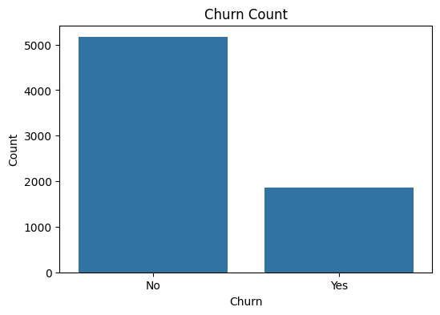

Observation:
The dataset contains a higher proportion of customers who did not churn compared to customers who churned.
- Approximately 73% of customers remained with the company.
- Approximately 27% of customers discontinued their services.
Interpretation:
Although churned customers represent a minority group, the proportion is significant enough to require predictive analysis. Identifying these customers early can help organizations implement targeted retention strategies.

7.2 Contract Type Analysis
Objective:
To analyze customer preferences across different contract types and understand their relationship with customer retention.
Visualization: Contract Type Distribution / Contract vs Churn
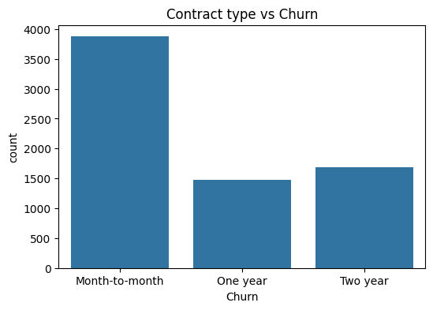
Observation:
- Around 54% of customers opted for month-to-month contracts.
- Approximately 22.75% preferred two-year contracts.
- The remaining customers selected one-year contracts.
Customers with month-to-month contracts showed a higher tendency to churn compared to customers with longer-term contracts.

Interpretation:
Customers with flexible contracts may have lower commitment and can switch providers more easily. Longer-term contracts appear to encourage customer retention.

7.3 Internet Service Analysis
Objective:
To examine customer distribution across different internet service categories.
Visualization: Internet Service vs Churn
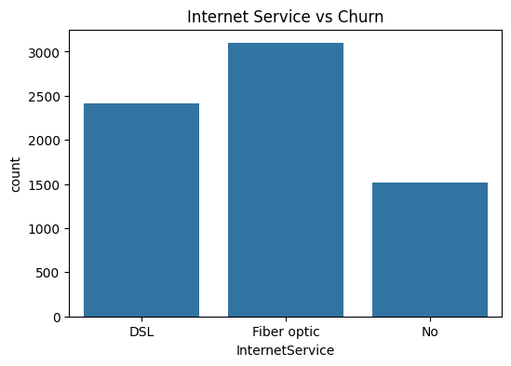
Observation:
- Approximately 43% of customers used Fiber optic services.
- Around 34% used DSL services.
- The remaining customers did not subscribe to internet services.
Differences in churn behaviour were observed across internet service categories.

Interpretation:
The type of internet service may influence customer satisfaction and retention. Customers using premium services may have higher expectations regarding performance and pricing.

7.4 Tenure Distribution by Churn
Objective:
To compare the duration of association with the company between churned and retained customers.
Visualization: Box Plot of Tenure vs Churn
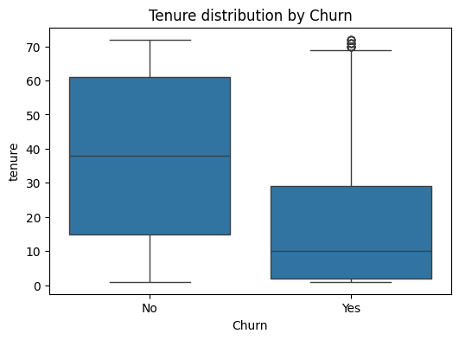
Observation:
- Non-churned customers generally have higher tenure.
- Churned customers tend to have shorter service durations.
Interpretation:
Customers in the early stages of their relationship with the company are more likely to churn. This highlights the importance of early customer engagement and onboarding strategies.

7.5 Monthly Charges Distribution by Churn
Objective:
To examine whether monthly billing amounts differ between churned and retained customers.
Visualization: Box Plot of MonthlyCharges vs Churn
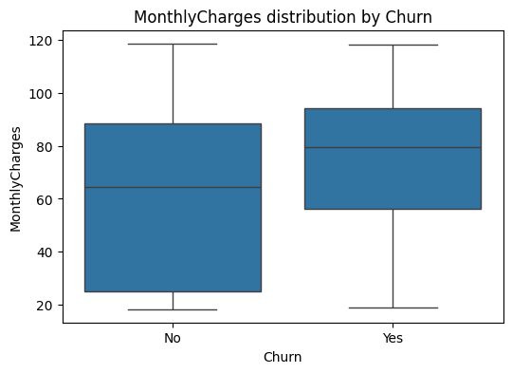
Observation:
- Churned customers generally have higher monthly charges compared to retained customers.
- The median monthly charge for churned customers is higher.
Interpretation:
Higher monthly charges may contribute to customer dissatisfaction if customers perceive that the service value does not justify the cost.

7.6 Total Charges Distribution by Churn
Objective:
To analyze differences in cumulative customer spending between churned and retained customers.
Visualization: Box Plot of TotalCharges vs Churn
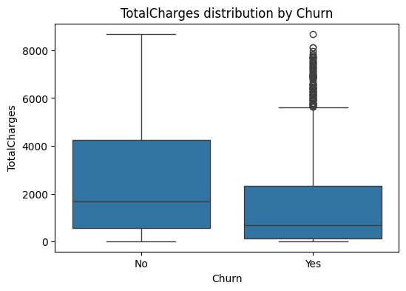
Observation:
- Retained customers generally have higher total charges.
- Churned customers show lower median total charges.
- Some high-value customers are present among churned customers.
Interpretation:
Lower total charges among churned customers are mainly associated with shorter customer tenure. However, the presence of high-value churned customers suggests that retention efforts should also focus on valuable customers.
7.7 Correlation Analysis
Objective:
To identify relationships between numerical variables.
Visualization: Correlation Heatmap
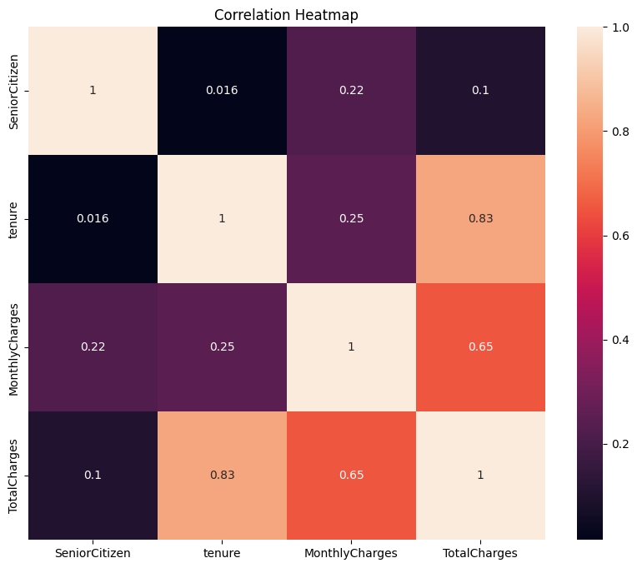
Observation:
- Tenure and TotalCharges showed a strong positive correlation (0.83).
- MonthlyCharges and TotalCharges showed a moderate positive correlation (0.65).

Interpretation:
Customers with longer tenure tend to accumulate higher total charges. This relationship indicates that customer lifetime value is strongly influenced by service duration.

Statistical Analysis
Statistical hypothesis testing was performed to validate the relationships observed during exploratory data analysis. The objective was to determine whether customer attributes have statistically significant relationships with customer churn behaviour.
A significance level of α = 0.05 was considered for all statistical tests.

8.1 Chi-Square Test of Independence
Objective:
To determine whether there is a statistically significant association between contract type and customer churn.
Since both variables are categorical:
- Contract Type:
  - Month-to-month
  - One year
  - Two year
- Churn:
  - Yes
  - No
the Chi-square test of independence was applied.

Hypotheses:
Null Hypothesis (H₀):
Contract type and customer churn are independent.
In other words:
Contract type does not have a significant relationship with customer churn.

Alternative Hypothesis (H₁):
Contract type and customer churn are dependent.
In other words:
Contract type is significantly associated with customer churn.

Test Results:
Test Statistic | Value
Chi-square statistic | 1179.55
Degrees of freedom | 2
p-value | 7.326 × 10⁻²⁵⁷

Decision:
The obtained p-value is significantly smaller than the significance level:
p-value = 7.326 × 10⁻²⁵⁷
Therefore, the null hypothesis is rejected.

Conclusion:
There is statistically significant evidence that contract type and customer churn are associated.

Interpretation:
The results indicate that customers with different contract types exhibit different churn behaviour. Customers with flexible month-to-month contracts are more likely to churn compared to customers with longer-term contracts.
This suggests that contract commitment plays an important role in customer retention.

8.2 Independent Samples Welch’s t-Test
Objective:
To determine whether the average monthly charges differ significantly between churned and retained customers.
The variable considered was:
- MonthlyCharges
Groups:
- Churned customers (Yes)
- Non-churned customers (No)
Since the comparison involved the means of two independent groups, Welch’s t-test was performed.

Hypotheses:
Null Hypothesis (H₀):
μ_{Churn=Yes} = μ_{Churn=No}
There is no significant difference in average monthly charges between churned and retained customers.

Alternative Hypothesis (H₁):
μ_{Churn=Yes} ≠ μ_{Churn=No}
There is a significant difference in average monthly charges between churned and retained customers.

Test Results:
Test Statistic | Value
t-statistic | 16.48
p-value | 6.76 × 10⁻⁶⁰

Decision:
Since p-value < 0.05 i.e.
p-value = 6.76 × 10⁻⁶⁰
the null hypothesis is rejected.

Conclusion:
There is statistically significant evidence that monthly charges differ between churned and non-churned customers.

Interpretation:
The analysis suggests that customers who churn have significantly different monthly charges compared to retained customers. From the exploratory analysis, churned customers were observed to have higher monthly charges, indicating that pricing and perceived service value may influence customer retention decisions.

Summary of Statistical Findings
Statistical Test | Variables Analysed | Result
Chi-Square Test | Contract Type vs Churn | Significant association found
Welch's t-Test | Monthly Charges vs Churn | Significant difference found

Overall Statistical Insight:
The hypothesis tests confirm the patterns identified during exploratory data analysis. Contract type and monthly charges are statistically significant factors associated with customer churn behaviour, suggesting that customer commitment level and pricing structure play important roles in retention.

Predictive Modelling and Machine Learning
Machine learning techniques were applied to develop a predictive model capable of identifying customers who are likely to churn. Since the target variable, Churn, represents two possible outcomes (Yes/No), this problem was formulated as a binary classification problem.
The objective of the predictive modelling phase was to build a model that could learn patterns from historical customer data and classify customers into churn and non-churn categories.

9.1 Data Preparation for Modelling
Before training the machine learning model, the dataset was prepared through the following steps:
Feature and Target Separation
The dataset was divided into:
- Independent Variables (X):
Customer-related features such as tenure, contract type, monthly charges, internet service, and other service attributes.
- Dependent Variable (y):
Customer churn status.
The target variable was encoded as:
- No churn → 0
- Churn → 1

Categorical Variable Encoding
Since machine learning algorithms require numerical inputs, categorical variables were converted into numerical representations using One-Hot Encoding.
Examples:
- Contract type
- Internet service
- Payment method
- Service subscriptions
This allowed the model to process categorical customer information effectively.

Feature Scaling
Feature scaling was applied using Standardization to bring numerical variables onto a comparable scale.
This step was necessary because variables such as:
- Tenure
- Monthly Charges
- Total Charges
have different ranges.

9.2 Train-Test Split
The dataset was divided into training and testing subsets:
- Training data: 80%
- Testing data: 20%
The training dataset was used to learn patterns, while the testing dataset was used to evaluate the model's performance on unseen data.

9.3 Logistic Regression Model
Model Selection
Logistic Regression was selected as the predictive model because:
- The problem involves binary classification.
- The model is computationally efficient.
- It provides interpretable results.
- It is suitable as a baseline model for churn prediction.
The model estimates the probability of a customer belonging to the churn category based on different customer characteristics.

Model Training
The Logistic Regression algorithm was trained using the processed training dataset.
The model learns relationships between customer attributes and churn behaviour, allowing it to predict whether a customer is likely to leave the service.

9.4 Model Evaluation
The trained model was evaluated using multiple performance metrics:
Accuracy
Measures the proportion of correctly classified customers.
Accuracy obtained:
78.96%

Precision
Measures how many customers predicted as churners actually churned.
Precision for churn class:
63%

Recall
Measures the ability of the model to correctly identify actual churned customers.
Recall for churn class:
50%

F1-score
Provides a balance between precision and recall.
F1-score for churn class:
56%

ROC-AUC Score
The ROC-AUC score measures the model's ability to distinguish between churn and non-churn customers.
ROC-AUC Score:
0.828

9.5 Model Performance Interpretation
The Logistic Regression model achieved an accuracy of approximately 79% and an ROC-AUC score of 0.828, indicating good predictive ability.
The model performed well in identifying customers who are likely to stay with the company. However, the recall for churned customers was comparatively lower, meaning that some customers who were actually at risk of leaving were not detected by the model.
Since customer retention strategies depend heavily on identifying potential churners, improving churn recall through techniques such as class balancing, advanced algorithms, or hyperparameter tuning could further enhance model performance.

9.6 Summary
The predictive modelling approach demonstrates how machine learning can support customer retention decisions by identifying patterns associated with churn. The Logistic Regression model provides a strong baseline solution and, when combined with statistical analysis, offers both predictive capability and interpretable insights into customer behaviour.

Results and Discussion
The analysis conducted in this study provided insights into customer characteristics associated with churn behaviour. The results obtained from exploratory data analysis, statistical testing, and machine learning modelling highlight the key factors influencing customer retention.

10.1 Exploratory Analysis Findings
The exploratory data analysis revealed several important patterns in customer behaviour.
Customer Churn Distribution
The dataset showed that approximately:
- 73% of customers remained with the company
- 27% of customers churned
Although the majority of customers were retained, the churn proportion indicates a significant customer retention challenge.

Tenure and Churn Relationship
The analysis showed that churned customers generally had lower tenure compared to retained customers.
This indicates that customers in the early stages of their relationship with the company are more likely to discontinue services. This may be due to dissatisfaction during the initial service period or a lack of customer engagement.

Monthly Charges and Churn Relationship
The analysis indicated that churned customers generally had higher monthly charges compared to retained customers.
This suggests that pricing and perceived value may influence customer decisions. Customers paying higher monthly fees may have greater expectations regarding service quality and benefits.

Total Charges and Customer Retention
Retained customers generally showed higher total charges because they had longer relationships with the company.
The presence of some high-value customers among churned users suggests that churn is not limited only to new customers, and valuable customers may also require targeted retention efforts.

10.2 Statistical Analysis Findings
Statistical hypothesis testing was performed to validate the relationships observed during EDA.

Contract Type and Churn
The Chi-square test showed a statistically significant association between contract type and churn behaviour.
Results:
- Chi-square statistic = 1179.55
- p-value = 7.326 × 10⁻²⁵⁷
Since the p-value was less than 0.05, the null hypothesis was rejected.
Discussion:
Contract type significantly influences customer retention. Customers with month-to-month contracts are more likely to churn compared to customers with longer-term contracts. This indicates that increasing customer commitment through longer contracts may improve retention.

Monthly Charges and Churn
The Welch’s t-test showed a statistically significant difference in monthly charges between churned and retained customers.
Results:
- t-statistic = 16.48
- p-value = 6.76 × 10⁻⁶⁰
The null hypothesis was rejected.
Discussion:
The results confirm that monthly charges differ significantly between churn groups. Higher monthly charges may contribute to customer dissatisfaction if customers perceive insufficient value from the services provided.

10.3 Machine Learning Results
A Logistic Regression model was developed to predict customer churn.
The model achieved:
Metric | Score
Accuracy | 78.96%
Precision (Churn) | 63%
Recall (Churn) | 50%
F1-score (Churn) | 56%
ROC-AUC Score | 0.828

Discussion of Model Performance
The model demonstrated good overall classification performance, achieving an ROC-AUC score of 0.828, which indicates that the model can effectively distinguish between churn and non-churn customers.
However, the recall for the churn class was 50%, meaning that the model identified only half of the customers who actually churned. This limitation is important because failing to identify potential churners may result in missed retention opportunities.
The results suggest that while Logistic Regression provides a reliable baseline model, future improvements could include handling class imbalance, applying advanced machine learning algorithms, and performing hyperparameter optimization.
10.4 Overall Discussion and Business Insights
The combined results indicate that customer churn is influenced by multiple factors, particularly:
- Contract type
- Customer tenure
- Monthly charges
- Service-related characteristics
The study suggests that companies can reduce churn by:
- Focusing retention efforts on new customers.
- Encouraging customers to move from flexible monthly contracts to longer-term plans.
- Reviewing pricing strategies for high-paying customers.
- Identifying high-risk customers through predictive analytics.
The integration of statistical analysis and machine learning provides both explanatory insights and predictive capability, allowing organizations to make more informed customer retention decisions.

